CREDIT CARD DEFAULT PREDICTION

Wireframe Documentation

Homepage

1.Home page of the credit card default prediction app shows the title of the project with a tag line also has two buttons, one to navigate us to predict page and another to start training.

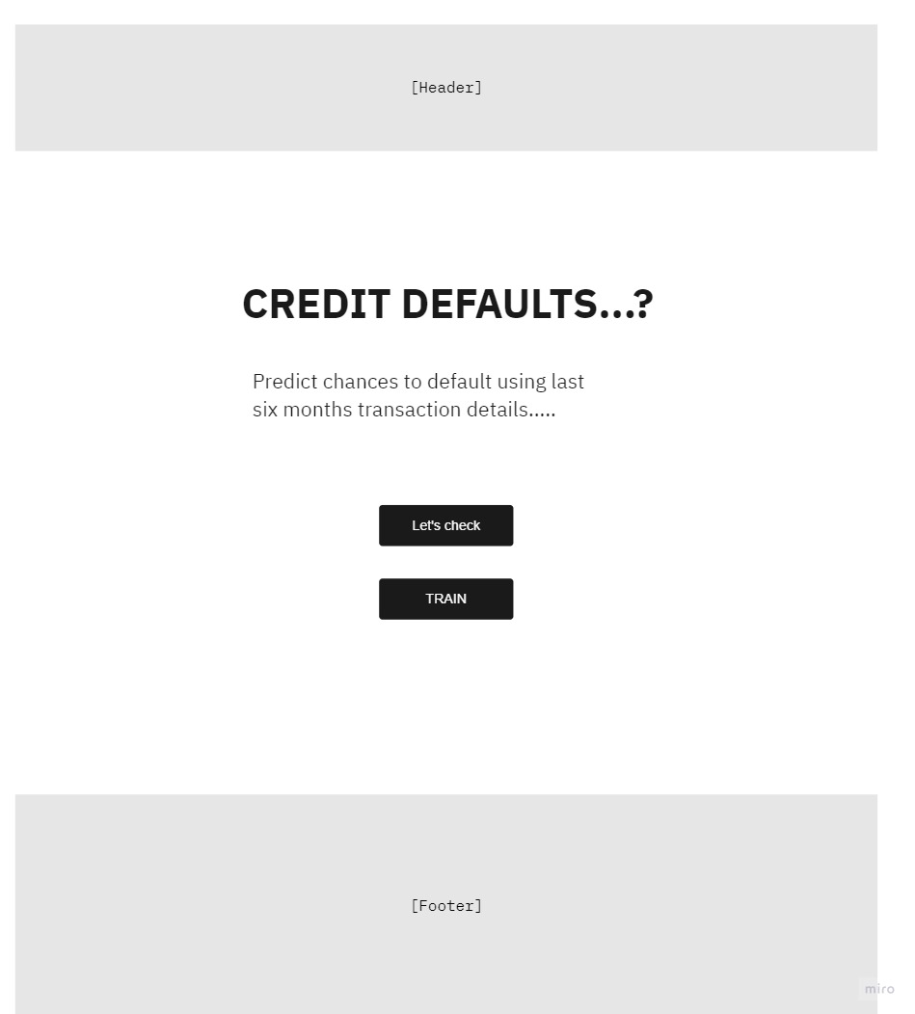

Predict page

This page we divided the box into grids, in each grid we have label of what data to input and the textbox to input the data.

One button also there on click which start the prediction.

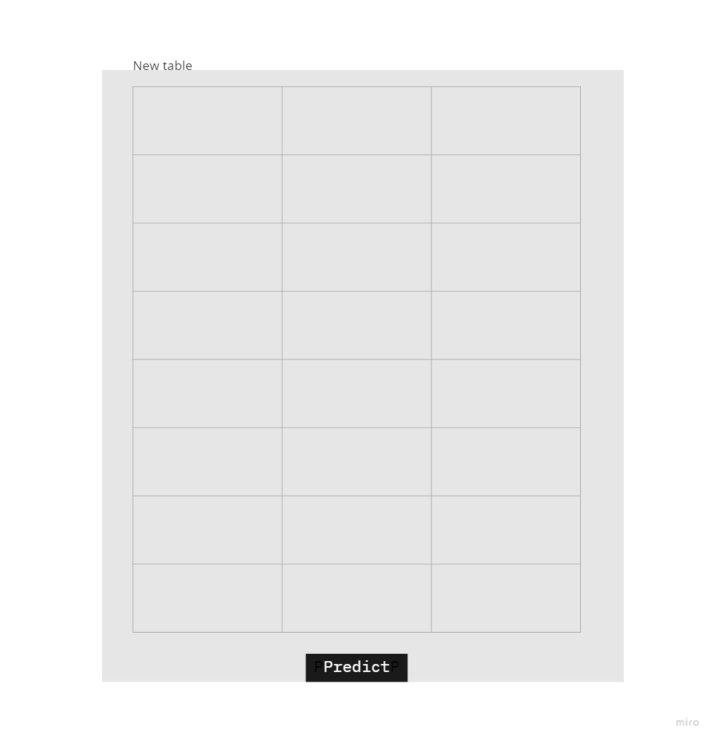

Result page

We have two result pages

1. Page which shows the customer won’t default payment.
2. Page which shows customer will default payment.

1.

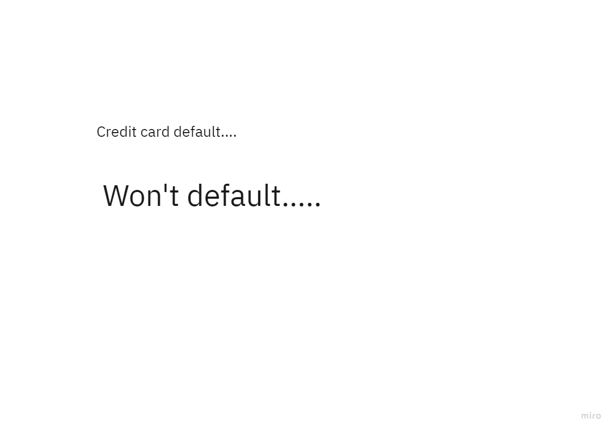

2.

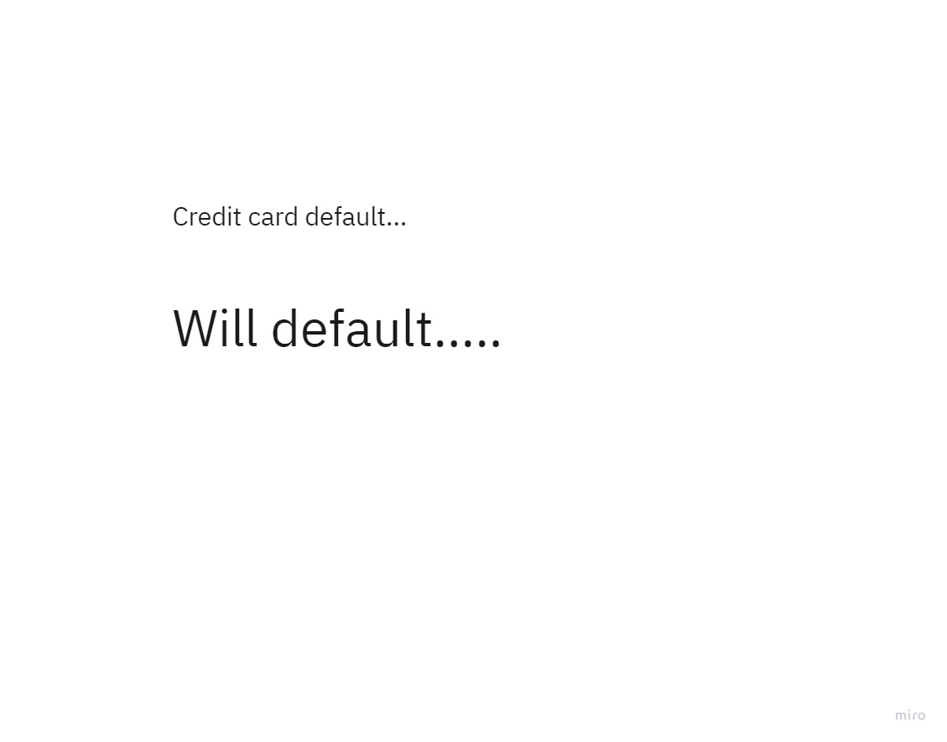

Training page

This web page shows once the training has completed successfully.

